# Model Organisms in Biological Research *(C. elegans)*

Understanding the human being as a functional unit comprised of an organism and its bacterial populations is the objective of the new and holistic approach to **metaorganism research** in Kiel. The aim of this cross-boundary area of biological research is to develop a holistic description and understanding of the principles of a metaorganism, how and whether bacteria and their hosts have adapted to one another in the course of evolution. Thanks to technical developments in genetic information decoding, researchers are just beginning to understand how the interaction of bacteria, organisms and the environment affect all areas of our lives. In order to obtain new insights in metaorganism research in the first place, we need trustworthy and honest scientists who publish results based on facts, and not as it serves their personal interests. Also, their work must be based on key questions and experiments which often arise as a result of problems. With the aid of such experiments, hypotheses are tested which are then either corroborated or refuted. This leads the scientist to new insights. Originally postulated hypotheses are often abandoned or must undergo further development. In this way, aided by progress in technology, existing knowledge can change over time (in school textbooks as well). New insights are possible only if experiments are repeated several times under the same conditions. For this reason, good theories are the result of a large number of different experiments and what is often a long period of testing. In order to achieve these advances, metaorganism research is often performed using model organisms.

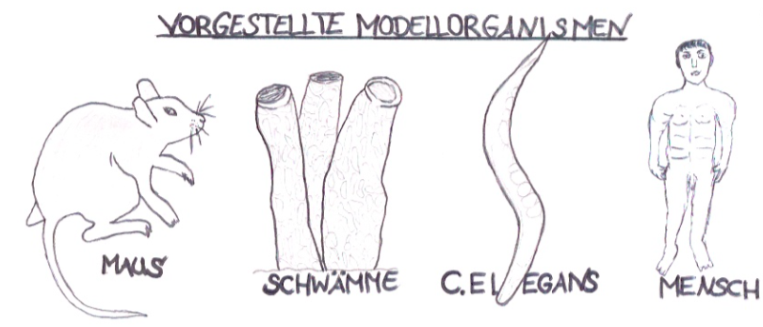

**Model organisms** are life forms (bacteria, fungi, plants or animals) which are used as test subjects in biological research. They possess characteristic attributes which allow the exploration of a specific topic.

Model organisms also provide easy access to experiments to better understand individual processes in animals, plants, fungi or microbes1. In order for an organism to be considered as a model, it must fulfill a large number of prerequisites. These can include: a short generation time2, inexpensive and unproblematic cultivation in the laboratory, a completely decoded genome[1] and various options for gene manipulation4. Which model is ultimately selected often depends on the research question being posed. For cellular biological research work unicellular life forms (e.g. non-pathogenic5 strains of bacteria) are particularly well suited. Multi-celled organisms (e.g. ***Caernorhabditis elegans*, sponges**) are the preferred choice for research in developmental biology. For studies in immunology, higher vertebrates such as **house mice** are especially suitable, as they have developed a complex immune system. Pharmacology works with the findings from animal research and transfers these to the **human organism** for purposes such as the creation of new medicines. On the following pages only **one** of a total of four model organisms (see figure) is presented.

Model organism: *C. elegans*

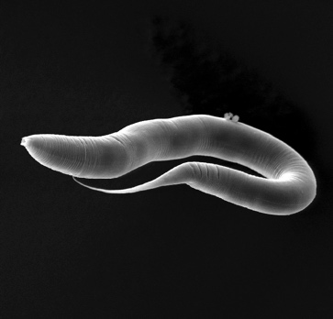

**Source:** Working group Schulenburg, University Kiel

**Name:** *Caenorhabditis elegans (translation from Greek/Latin “elegant new rod“, often abbreviated to* ***C. elegans***

**Phylum:** threadworms (nematodes)

**Size:** approx. 0.5 -1.2 mm long

**Genome known in its entirety:** over20,000 genes (1998)

**Life expectancy:** 2-3 weeks

Although the untrained observer might not even notice the threadworm *C. elegans* at first with its small size and translucent appearance, it holds a prominent position in biological resarch. *C. elegans* is one of the main biological model organisms due to its many characteristics which are advantageous in research. These include its genome, which has been known in its entirety since 1998, the fact that threadworms are simple and inexpensive to keep in the laboratory, a short generation time of about three days, large number of progeny per worm (250-350), many previous successful gene manipulations, and the possibility of freezing the worm to -80 degrees Celcius and then resuscitating it on thawing. In addition, its translucent appearance makes it possible to follow the developmental steps of each cell from outside under a microscope. As it is small in size (around 1 millimeter) and has a single bacterial food source, up to 100,000 individuals can grow in a petri dish prepared with agar6 and a bacterial lawn. Many laboratory experiments on *C. elegans* are conducted using only the N2 strain, however. As this strain of *C. elegans* exhibits significant adaptations to laboratory work methods, it differs greatly from the threadworms found in the field.

Humans and *C. elegans* – they have more in common than we think

It may not seem so at first glance, but *C. elegans* and humans have more in common than we think. About 42% of the genes in *C. elegans* can also be found in the human genome because humans and threadworms have shared a piece of their long evolutionary path with one another. For example, *C. elegans* was found to contain genes which control the aging process, and that there are regulated cells in the organism which are capable of sending other cells to a programmed death (*apoptosis*). The presence of these complex mechanisms in the threadworm indicates that they appeared very early in the evolution of multi-celled organisms and have prevailed all the way to the human. They are what might be called the ‘recipes for success’ across history and were handed down again and again over the course of animal evolution.

6 Is a good breeding ground for microorganisms and consists of the cell walls of a species of algae from East Asia

Microbiome research on worms with promising insights

The modest count of around 1000 somatic cells7, coupled with the genetic complexity of the threadworm, make it possible for us to obtain an impression of the animal as overall system in order to understand the worm as meta-organism.

Among the scientists working with *C. elegans* in the laboratory is the evolutionary biologist Dr. Hinrich Schulenburg at the Christian-Albrechts-Universität in Kiel. Together with his research team, Professor Schulenburg is currently attempting to determine how the microbiome8 of the worm in its natural habitat is structured. In his studies he has proven, among other results, that the worm possesses helpful microorganisms which increase the growth of *C. elegans* populations9 as well as the resistance of the worm to outside influences such as stress, extreme temperatures and disease-causing germs. These insights can make a valuable contribution for future microbiome research on animals from the worm to the human.

**References:**

* Alberts, Johnson, Lewis, Raff, Roberts, Walter (2004): [Molekularbiologie](https://www.gesundheitsindustrie-bw.de/de/fachbeitrag/dossier/modellorganismen/#glossar365) der Zelle; 4. Auflage; WILEY-VCH Verlag GmbH & Co. KgaA, Weinheim.
* Bang C, Dagan T, Deines P, Dubilier N, Duschl WJ, Fraune S, Hentschel U, Hirt H, Hülter N, Lachnit T, Picazo D, Galan PL, Pogoreutz C, Rädecker N, Saad M M, Schmitz R A, Schulenburg H, Voolstra CR, Weiland-Bräuer N, Ziegler M, Bosch TCG (2018) Metaorganisms in extreme environments: do microbes play a role in organismal adaptation? Zoology in press.
* BIOPRO Baden-Württemberg GmbH (2009): <https://www.gesundheitsindustrie-bw.de/de/fachbeitrag/dossier/modellorganismen/> (Abgerufen am 16.06.18)
* Burke H. Judd: *Experimental Organisms Used in Genetics.* In: *Encyclopedia of Life Sciences.* John Wiley & Sons Inc., Chichester 2001, <http://www.els.net/>, doi:[10.1038/npg.els.0000814](http://dx.doi.org/10.1038%2Fnpg.els.0000814) (Abgerufen am 16.06.18)
* Freudig, D., Sauermost, R. (1999) Modellorganismen. Spektrum der Wissenschaft. URL: <https://www.spektrum.de/lexikon/biologie/modellorganismen/43448> (Abgerufen am 12.06.18)
* Origin and Function of Metaorganisms – Sonderforschungsbereich 1182: <https://www.metaorganism-research.com/de/> (Abgerufen am 20.06.18)

7 Body cells which are incapable of producing sex cells (gametes). *C. elegans* is either a hermaphrodite (which first produces sperm and then oocytes) and reproduces through self-fertilization, or it is a male which mates with hermaphrodites and is capable of reproducing sexually. The male possesses 1031 somatic cells, the hermaphrodite 959.

8 Totality of microorganisms which populate the worm.

9 Groups of individuals of a species which are found in a particular area or region.

Advantages:

Disadvantages:

Additional task:

Discuss the advantages and disadvantages of using *C. elegans* as model organism.

Task 1:

Work together in the expert group to formulate **three** key statements from the text.

At a glance:

1.

2.

3.

**Mouse:**

1.

2.

3.

**Sponge:**

1.

2.

3.

**Human:**

1.

2.

3.

Task 2:

List the **three** key statements for the other **three** model organisms presented (mouse, sponge and human).

1. Microbe is a short form of the word microorganism. Microorganisms are minute life forms which surround us. The most common microbes are bacteria, viruses and fungi.

   2 Average time period between two successive generations.

   3 The totality of genes is known.

   4 This means to alter genes or to switch them on and off.

   5 Bacteria which do not cause illness