# Model Organisms in Biological Research (Human)

Understanding the human being as a functional unit comprised of an organism and its bacterial populations is the objective of the new and holistic approach to **metaorganism research** in Kiel. The aim of this cross-boundary area of biological research is to develop a holistic description and understanding of the principles of a metaorganism, how and whether bacteria and their hosts have adapted to one another in the course of evolution. Thanks to technical developments in genetic information decoding, researchers are just beginning to understand how the interaction of bacteria, organisms and the environment affect all areas of our lives. In order to obtain new insights in metaorganism research in the first place, we need trustworthy and honest scientists who publish results based on facts, and not as it serves their personal interests. Also, their work must be based on key questions and experiments which often arise as a result of problems. With the aid of such experiments, hypotheses are tested which are then either corroborated or refuted. This leads the scientist to new insights. Originally postulated hypotheses are often abandoned or must undergo further development. In this way, aided by progress in technology, existing knowledge can change over time (in school textbooks as well). New insights are possible only if experiments are repeated several times under the same conditions. For this reason, good theories are the result of a large number of different experiments and what is often a long period of testing. In order to achieve these advances, metaorganism research is often performed using model organisms.

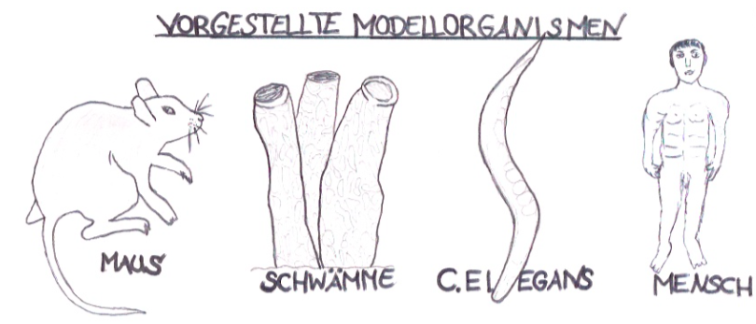

**Model organisms** are life forms (bacteria, fungi, plants or animals) which are used as test subjects in biological research. They possess characteristic attributes which allow the exploration of a specific topic.

Model organisms also provide easy access to experiments to better understand individual processes in animals, plants, fungi or microbes1. In order for an organism to be considered as a model, it must fulfill a large number of prerequisites. These can include: a short generation time2, inexpensive and unproblematic cultivation in the laboratory, a completely decoded genome[1] and various options for gene manipulation4. Which model is ultimately selected often depends on the research question being posed. For cellular biological research work unicellular life forms (e.g. non-pathogenic5 strains of bacteria) are particularly well suited. Multi-celled organisms (e.g. ***Caernorhabditis elegans*, sponges**) are the preferred choice for research in developmental biology. For studies in immunology, higher vertebrates such as **house mice** are especially suitable, as they have developed a complex immune system. Pharmacology works with the findings from animal research and transfers these to the **human organism** for purposes such as the creation of new medicines. On the following pages only **one** of a total of four model organisms (see figure) is presented.

Model organism: the human

**Source:** Illustrations from the figure IPN

**Name:** Human (Latin: *Homo sapiens*)

**Completely sequenced genome:** 2003

**Genes:** approx. 40,000

**Gestation period:** approx. 9 months

**Size of litter:** one offspring on average

**Average life expectancy (born today):** 78 years for males, 83 years for females

**Average height (in Germany):** 1.80 m for males, 1.66 m for females

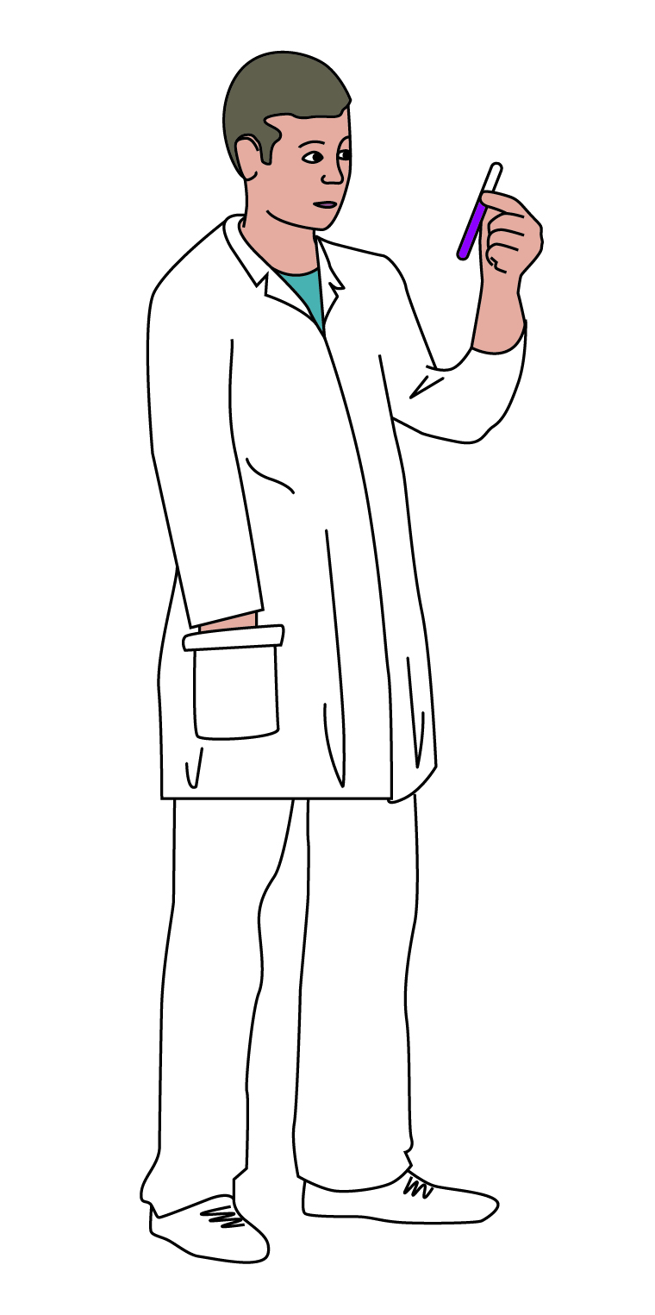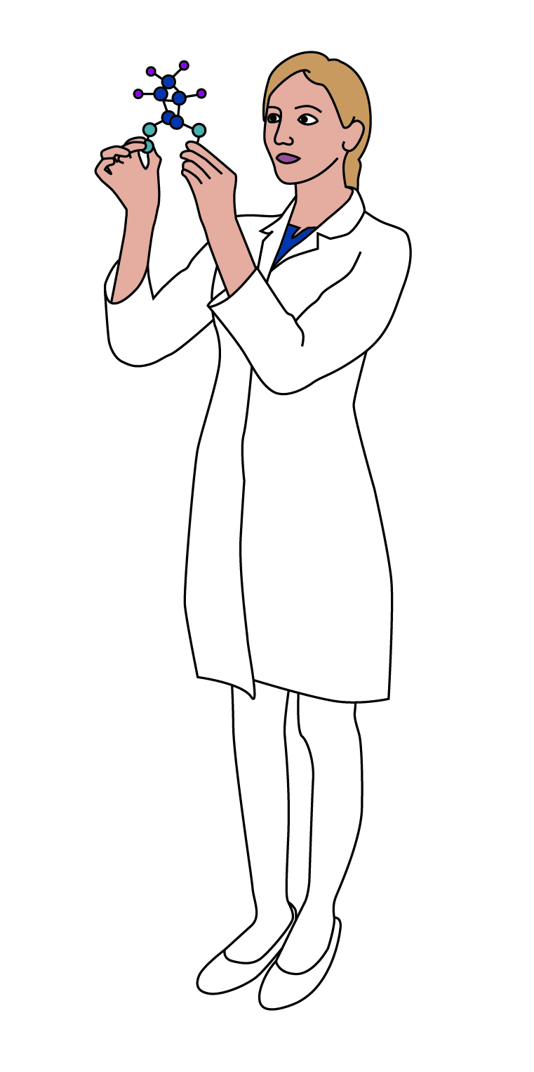

The 21st century represents a revolution in the way humans obtain and process information. One of the new achievements during this period is the ever-advancing decoding of genetic information from animals, plants and microorganisms. This is one of the most important prerequisites for tasks such as investigating human diseases, understanding their causes and developing new forms of therapy. However, the increase in life expectancy, changes in environmental conditions, and variations in human lifestyle spawn new diseases, or result in an increased occurrence of already known diseases in industrialized countries such as Germany. These consistently pose new medical challenges to researchers.

One example of the continuously increasing number of diseases in Germany is type 2 diabetes, which is often diagnosed in overweight adolescents. Another example is the increased occurrence of infections with *Clostridium difficile*, which can be caused by overdosing with antibiotics. At this point, research on metaorganisms could act as an aid in the further examination of our microbiome6. Researchers have already discovered that the microorganisms which inhabit us can have an effect on our behavior, our weight and our health. If we alter our eating habits, for example, the composition of our intestinal bacteria also changes.

Researchers who have dealt more closely with the human biome can recognize simply from a stool sample whether the person providing it suffers from diabetes or chronic inflammatory intestinal diseases. The researcher can also say with reasonable certainty whether the person is of normal weight or is overweight and if the person eats large amounts of meat or abstains from it completely. Thanks to the great strides made in sequencing methods and bioinformatics, microbiome research has become one of the leading areas of biological research in the past ten years. The balance between health and disease can have something to do with the diversity of microbes within the host organism. The questions faced in microbial research in the future will therefore involve what effects bacteria have and how we can keep our microbiome healthy or bring it back to health.

One scientist who is performing further studies on the microbiomes of humans and other animals is Dr. Felix Sommer. Together with other scientists at the Institut für Klinische Molekularbiologie (Institute for Clinical Molecular Biology) (IKMB) of the Christian-Albrechts-Universität in Kiel, he is currently studying the effects of poor nutrition and calorie restriction on a host organism, as well as how the microbiota and intestinal epithelium react. In performing these experiments he uses mice as model organisms.

6 This refers to the totality of microorganisms (biome) which populates humans and other life forms.

Researchers have investigated this phenomenon. They discovered that every sponge is equipped with its own survival strategies which make use of biochemical substances. These strategies include such tactics as producing glycoproteins to protect against freezing, poisons as defense against predators, antibiotic substances to prevent the outer skin from being overgrown by bacteria (referred to as *biofouling*), and the production of substances against harmful bacteria which can enter the body through the influx of water.

An example of the important role of model organisms in biological research is the enormous number of different life forms that are selected for use, depending on the topic and research question under investigation. If research were not performed on such animals, the side effects of newly developed medicines would have to be tested directly on humans. Research and work performed on humans involve strict, all-encompassing safety measures which serve to protect the research subject and ensure compliance with scientific standards. In order to obtain information despite these strictures, model organisms can provide initial insights into any side effects medicines may have on humans. Often however, studies on humans are and remain essential to research.

**References:**

* Alberts, Johnson, Lewis, Raff, Roberts, Walter: [Molekularbiologie](https://www.gesundheitsindustrie-bw.de/de/fachbeitrag/dossier/modellorganismen/#glossar365) der Zelle; (2004) 4. Auflage; WILEY-VCH Verlag GmbH & Co. KgaA, Weinheim.
* Bang C, Dagan T, Deines P, Dubilier N, Duschl WJ, Fraune S, Hentschel U, Hirt H, Hülter N, Lachnit T, Picazo D, Galan PL, Pogoreutz C, Rädecker N, Saad M M, Schmitz R A, Schulenburg H, Voolstra CR, Weiland-Bräuer N, Ziegler M, Bosch TCG (2018) Metaorganisms in extreme environments: do microbes play a role in organismal adaptation? Zoology in press.
* BIOPRO Baden-Württemberg GmbH (2009): <https://www.gesundheitsindustrie-bw.de/de/fachbeitrag/dossier/modellorganismen/> (Abgerufen am 16.06.18).
* Bosch, T.C.G. (2017), Der Mensch als Holobiont – Mikroben als Schlüssel zu einem neuen Verständnis von Leben und Gesundheit. Verlag Ludwig, Kiel.
* Burke, H. Judd: Experimental Organisms Used in Genetics; ENCYCLOPEDIA OF LIFE SCIENCES © 2001, John Wiley & Sons, Ltd.
* Freudig, D., Sauermost, R. (1999) Modellorganismen. Spektrum der Wissenschaft. URL: <https://www.spektrum.de/lexikon/biologie/modellorganismen/43448> (letzter Zugang 12.06.18)
* Stellungnahme der Deutschen Forschungsgemeinschaft (DFG)(1999): Perspektiven der Genomforschung: <http://www.dfg.de/download/pdf/dfg_im_profil/reden_stellungnahmen/archiv_download/st_genom_99.pdf> (Abgerufen am 05.07.18)
* Origin and Function of Metaorganisms – Sonderforschungsbereich 1182: <https://www.metaorganism-research.com/de/> (Abgerufen am 19.06.18).

Advantages:

Disadvantages:

Additional task:

Summarize the advantages and disadvantages of using model organisms in performing research for humans.

Task 1:

Work together in the expert group to formulate **three** key statements from the text.

At a glance:

1.

2.

3.

**Mouse:**

1.

2.

3.

***C. elegans*:**

1.

2.

3.

**Sponge:**

1.

2.

3.

Task 2:

List the **three** key statements for the other **three** model organisms presented (mouse, *C.* *elegans* and sponge).

1. Microbe is a short form of the word microorganism. Microorganisms are minute life forms which surround us. The most common microbes are bacteria, viruses and fungi.

   2 Average time period between two successive generations.

   3 The totality of genes is known.

   4 This means to alter genes or to switch them on and off.

   5 Bacteria which do not cause illness