# Model Organisms in Biological Research (Mouse)

Understanding the human being as a functional unit comprised of an organism and its bacterial populations is the objective of the new and holistic approach to **metaorganism research** in Kiel. The aim of this cross-boundary area of biological research is to develop a holistic description and understanding of the principles of a metaorganism, how and whether bacteria and their hosts have adapted to one another in the course of evolution. Thanks to technical developments in genetic information decoding, researchers are just beginning to understand how the interaction of bacteria, organisms and the environment affect all areas of our lives. In order to obtain new insights in metaorganism research in the first place, we need trustworthy and honest scientists who publish results based on facts, and not as it serves their personal interests. Also, their work must be based on key questions and experiments which often arise as a result of problems. With the aid of such experiments, hypotheses are tested which are then either corroborated or refuted. This leads the scientist to new insights. Originally postulated hypotheses are often abandoned or must undergo further development. In this way aided by progress in technology, existing knowledge can change over time (in school textbooks as well). New insights are possible only if experiments are repeated several times under the same conditions. For this reason, good theories are the result of a large number of different experiments and what is often a long period of testing. In order to achieve these advances metaorganism research is often performed using model organisms.

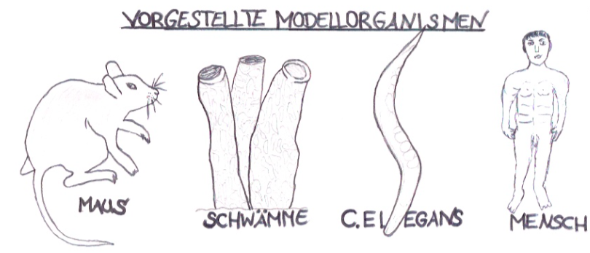

**Model organisms** are life forms (bacteria, fungi, plants or animals) which are used as test subjects in biological research. They possess characteristic attributes which allow the exploration of a specific topic.

Model organisms also provide easy access to experiments to better understand individual processes in animals, plants, fungi or microbes1. In order for an organism to be considered as a model, it must fulfill a large number of prerequisites. These can include: a short generation time2, inexpensive and unproblematic cultivation in the laboratory, a completely decoded genome[1] and various options for gene manipulation4. Which model is ultimately selected often depends on the research question being posed. For cellular biological research work unicellular life forms (e.g. non-pathogenic5 strains of bacteria) are particularly well suited. Multi-celled organisms (e.g. ***Caernorhabditis elegans*, sponges**) are the preferred choice for research in developmental biology. For studies in immunology, higher vertebrates such as **house mice** are especially suitable, as they have developed a complex immune system. Pharmacology works with the findings from animal research and transfers these to the **human organism** for purposes such as the creation of new medicines. On the following pages only **one** of a total of four model organisms (see figure) is presented.

Model organism: the sponge

**Source:** Photo by Janet Stephens. Published in Wikipedia – Wistar Rat (2001): <https://de.wikipedia.org/wiki/Rat_Park#/media/File:Wistar_rat.jpg> (accessed on July 10, 2018)

**Origin**: house mouse (Latin: *Mus musculus*) 🡪 cross between three sub-species (hybrid)

**Completely sequenced genome:** 2002

**Number of genes:** approx. 24,000

**Gestation period:** approx. 3 weeks

**Litter size:** 10 or more offspring

**Appearance (color of fur):** wild type - brown, other strains - black, albino laboratory mouse - white

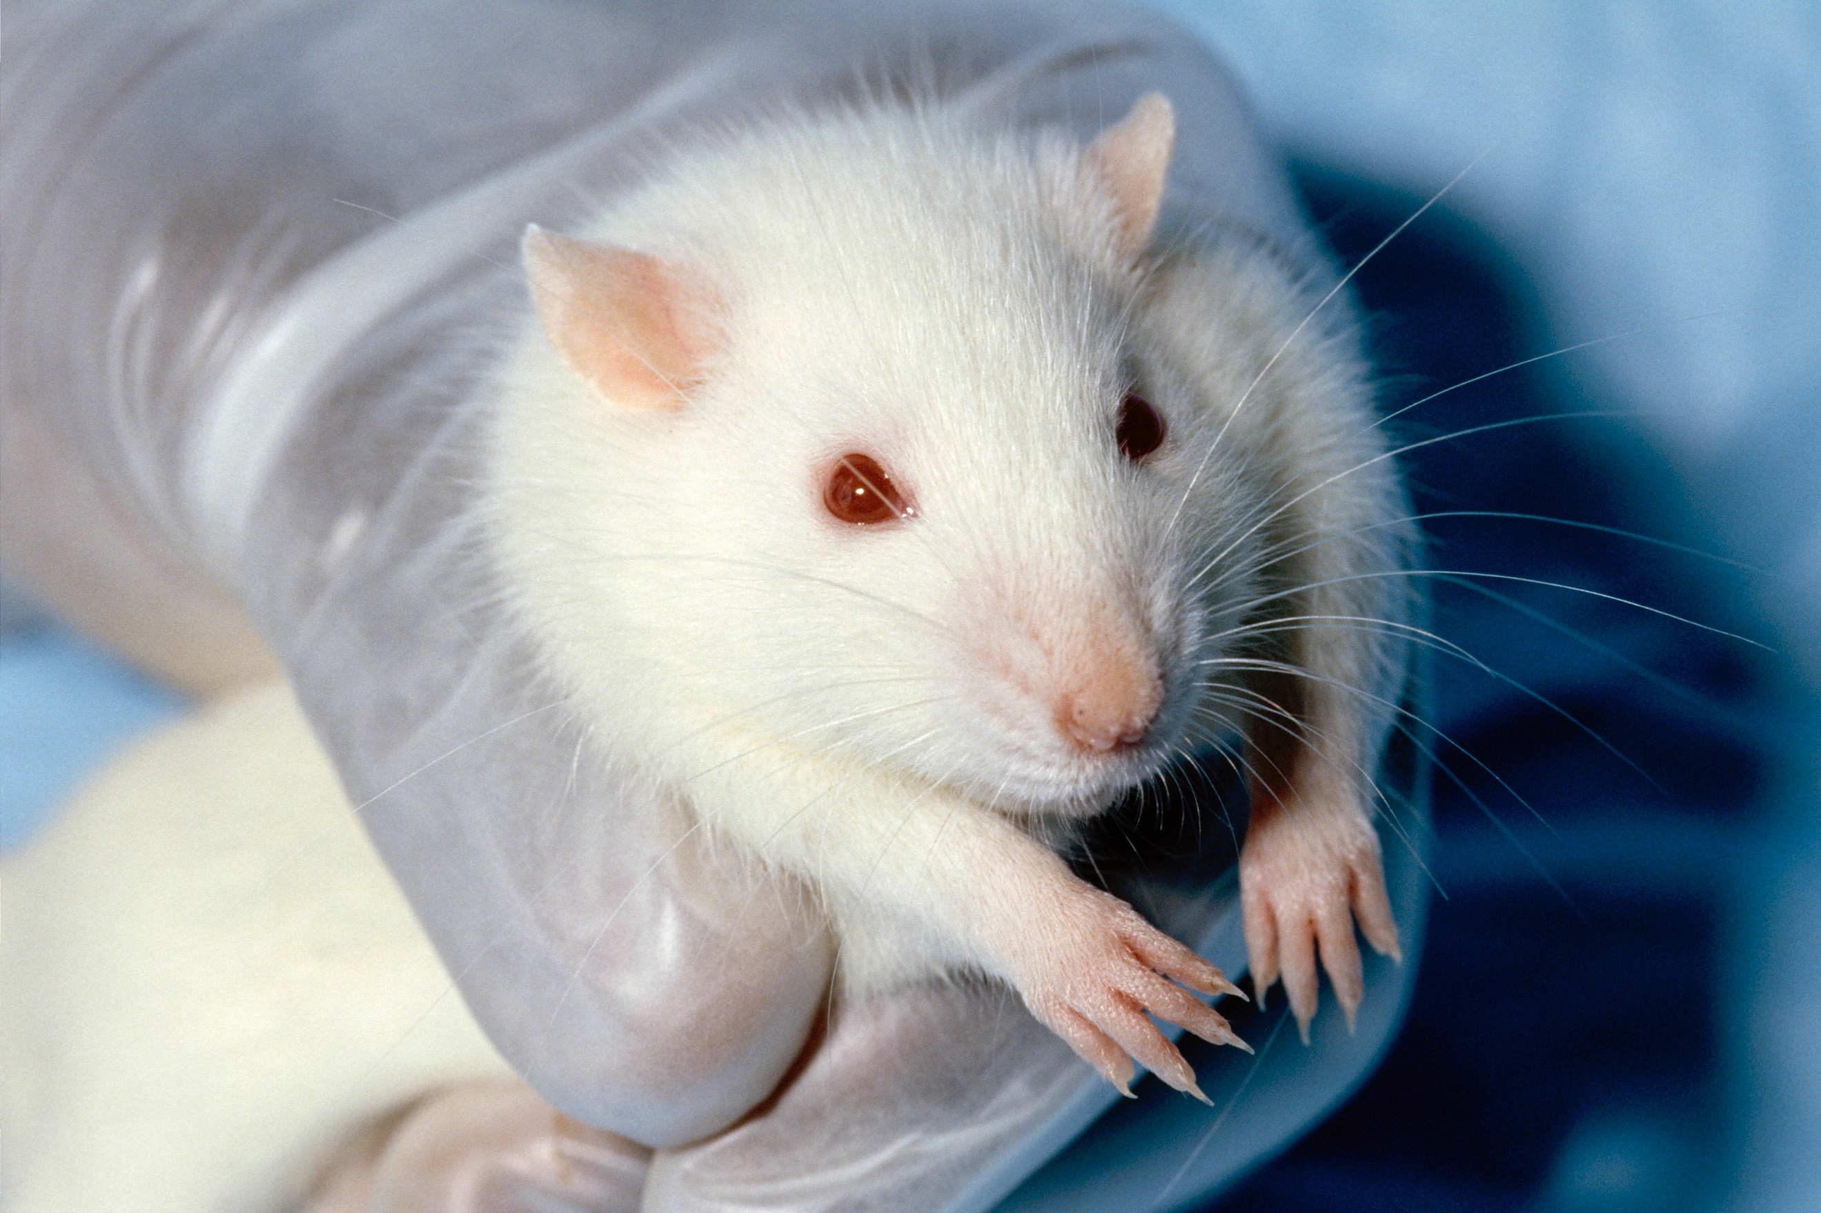

The mouse (Latin: *Mus musculus*) is the mammal most commonly used in animal research studies. Used at the start of the 20th century mainly in cancer research experiments, it is now an indispensable model organism in many research areas such as behavioral research and in studies on human disease. This is due above all to the fact that the size of the mouse genome is similar to that of humans and that over 90% of the genes in a mouse are also present in similar form in humans. Additionally, mice are inexpensive and easy to keep in a laboratory; they have a life cycle of one to two years, which is short among mammals; their generation time of ten weeks is also short; and their complete genome has been sequenced since 2002.

Creating a new species according to human conceptions

The mouse most widely used in research today is a hybrid and is thus called the ‘laboratory mouse’. This means that the genetic material of the mouse is made up of that from three sub-species. This serves the objective of achieving genetic uniformity which involves fewer variants than are encountered in wild mice. As a rule, the laboratory mouse mates within close families, thereby creating inbred lines6 which can provide researchers with exact and comparable results over several generations. By selectively switching the genes in the laboratory mice on and off, the function of these genes can be more closely determined. In recent years above all, however, more and more doubts have arisen in particular branches of science as to whether mice are actually so suitable for use as model organisms. Despite high genetic correspondence, repeated difficulties have been encountered in transferring results to humans. One reason for this is that the mouse genome contains 1000 more genes than that of the human. Also, inflammatory processes operate differently in mice than they do in humans. Moreover, there is too great a difference in the lifespan, evolutionary history and living conditions of mice when it comes to making prognoses regarding the effects of medications on humans.

Must insights for the benefit of humanity be gained at the expense of animal welfare?

In Germany, animal research testing on vertebrates is strictly controlled and requires regulatory approval. The term animal testing in general refers to medical intervention on or treatment of an animal which may cause the animal pain, damage or suffering. Scientists are bound by legal requirements to hold the number of genetically modified mice suffering severe stress or disease as low as possible. This includes ensuring that the animals are kept in a manner which is appropriate to the species and is reproducible. The strict requirements also include the EC directive on animal protection in research (2010) which is based on the principle of the three Rs: reduction

and refinement of animal experiment methods and the development of methods to replace and supplement animal tests. One alternative method is referred to as in vitro testing. This term refers to experiments which are conducted in test tubes or similar in the laboratory and thus take place outside an organism. In addition, computer simulations are used or a combination of both methods is selected. Animal models using the mouse make it possible to perform holistic investigations on complex organisms which are indispensable in gaining many further biological insights. This is why in 2016 2.8 million animals were used for scientific purposes; just under half of these (1.2 million) were genetically modified and 86% of these were mice.

Among the scientists working in depth on mice as model organisms is Dr. John Baines. Together with his team at the Institut für Experimentelle Medizin (Institute for Experimental Medicine) at the Christian-Albrechts-Universität in Kiel, Professor Baines is studying whether the geographic distribution of house mice has any effect on the diversity of intestinal microbiota.

**References:**

* Alberts, Johnson, Lewis, Raff, Roberts, Walter: [Molekularbiologie](https://www.gesundheitsindustrie-bw.de/de/fachbeitrag/dossier/modellorganismen/#glossar365) der Zelle; (2004) 4. Auflage; WILEY-VCH Verlag GmbH & Co. KgaA, Weinheim.
* Bang C, Dagan T, Deines P, Dubilier N, Duschl WJ, Fraune S, Hentschel U, Hirt H, Hülter N, Lachnit T, Picazo D, Galan PL, Pogoreutz C, Rädecker N, Saad M M, Schmitz R A, Schulenburg H, Voolstra CR, Weiland-Bräuer N, Ziegler M, Bosch TCG (2018) Metaorganisms in extreme environments: do microbes play a role in organismal adaptation? Zoology in press.
* BERICHT DER KOMMISSION AN DEN RAT UND DAS EUROPÄISCHE PARLAMENT (2010): Sechster Bericht über die statistischen Angaben zur Anzahl der in den Mitgliedstaaten der Europäischen Union für Versuchs- und andere wissenschaftliche Zwecke verwendeten Tiere SEK(2010) 1107. Brüssel. <https://eur-lex.europa.eu/LexUriServ/LexUriServ.do?uri=COM:2010:0511:REV1:DE:PDF> (Abgerufen am 20.06.18).
* BIOPRO Baden-Württemberg GmbH (2009): <https://www.gesundheitsindustrie-bw.de/de/fachbeitrag/dossier/modellorganismen/> (Abgerufen am 16.06.18).
* Burke, H. Judd (2001): Experimental Organisms Used in Genetics; ENCYCLOPEDIA OF LIFE SCIENCES, John Wiley & Sons, Ltd.
* Bosch, T.C.G. (2017), Der Mensch als Holobiont – Mikroben als Schlüssel zu einem neuen Verständnis von Leben und Gesundheit. Verlag Ludwig, Kiel.
* Exner, C., Limbach, C. (2016): Senatskommission für tierexperimentelle Forschung der Deutschen Forschungsgemeinschaft (DFG) - Tierversuche in der Forschung: <https://www.uni-heidelberg.de/md/ibf/info/dfg_tierversuche.pdf> (Abgerufen am 05.07.18).
* Freudig, D., Sauermost, R. (1999) Modellorganismen. Spektrum der Wissenschaft. URL: <https://www.spektrum.de/lexikon/biologie/modellorganismen/43448> (Abgerufen am 12.06.18).
* Linnenbrink M*, Wang J*, Hardouin E, Künzel S, Metzler D, Baines JF, (2013).  The role of biogeography in shaping diversity of the intestinal microbiota in house mice. Mol. Ecol. in press.
* Max-Planck-Gesellschaft (2018) Modellorganismus Maus: <https://www.mpg.de/10888337/maus> (Abgerufen am 04.07.18).

Advantages:

Disadvantages:

Additional task:

Discuss the advantages and disadvantages of using the mouse as model organism.

Task 1:

Work together in the expert group to formulate **three** key statements from the text.

At a glance:

1.

2.

3.

**Sponge:**

1.

2.

3.

***C. elegans:***

1.

2.

3.

**Human:**

1.

2.

3.

Task 2:

List the **three** key statements for the other **three** model organisms presented (sponge, *C.* *elegans* and human).

1. Microbe is a short form of the word microorganism. Microorganisms are minute life forms which surround us. The most common microbes are bacteria, viruses and fungi.

   2 Average time period between two successive generations.

   3 The totality of genes is known.

   4 This means to alter genes or to switch them on and off.

   5 Bacteria which do not cause illness