# Model Organisms in Biological Research (Sponge)

Understanding the human being as a functional unit comprised of an organism and its bacterial populations is the objective of the new and holistic approach to **metaorganism research** in Kiel. The aim of this cross-boundary area of biological research is to develop a holistic description and understanding of the principles of a metaorganism, how and whether bacteria and their hosts have adapted to one another in the course of evolution. Thanks to technical developments in genetic information decoding, researchers are just beginning to understand how the interaction of bacteria, organisms and the environment affect all areas of our lives. In order to obtain new insights in metaorganism research in the first place, we need trustworthy and honest scientists who publish results based on facts, and not as it serves their personal interests. Also, their work must be based on key questions and experiments which often arise as a result of problems. With the aid of such experiments, hypotheses are tested which are then either corroborated or refuted. This leads the scientist to new insights. Originally postulated hypotheses are often abandoned or must undergo further development. In this way, aided by progress in technology, existing knowledge can change over time (in school textbooks as well). New insights are possible only if experiments are repeated several times under the same conditions. For this reason, good theories are the result of a large number of different experiments and what is often a long period of testing. In order to achieve these advances, metaorganism research is often performed using model organisms.

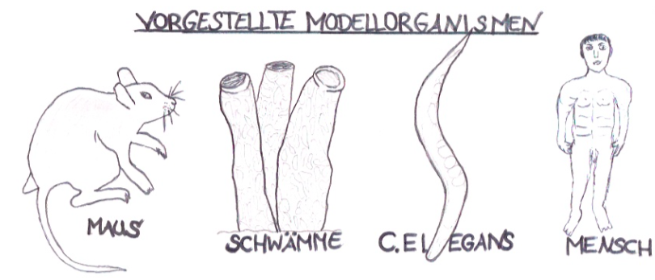

**Model organisms** are life forms (bacteria, fungi, plants or animals) which are used as test subjects in biological research. They possess characteristic attributes which allow the exploration of a specific topic.

Model organisms also provide easy access to experiments to better understand individual processes in animals, plants, fungi or microbes1. In order for an organism to be considered as a model, it must fulfill a large number of prerequisites. These can include: a short generation time2, inexpensive and unproblematic cultivation in the laboratory, a completely decoded genome[1] and various options for gene manipulation4. Which model is ultimately selected often depends on the research question being posed. For cellular biological research work unicellular life forms (e.g. non-pathogenic5 strains of bacteria) are particularly well suited. Multi-celled organisms (e.g. ***Caernorhabditis elegans*, sponges**) are the preferred choice for research in developmental biology. For studies in immunology, higher vertebrates such as **house mice** are especially suitable, as they have developed a complex immune system. Pharmacology works with the findings from animal research and transfers these to the **human organism** for purposes such as the creation of new medicines. On the following pages only **one** of a total of four model organisms (see figure) is presented.

Model organism: the sponge

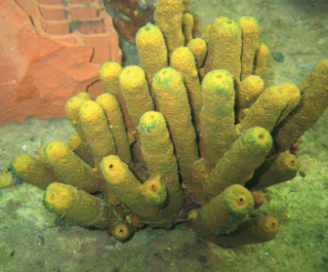

**Source:** Hentschel U., Piel J. (2006), Abenteuer im Metagenom, Nicht kultivierte Bakterien – die versteckte Vielfalt. Vorbild Natur, 77.

**Name:** Sponges (Latin: *Porifera*)

**Three classes:** *Demospongia* (demosponges, 95% of extant species),   
*Hexactinellida* (glass sponges), *Calcarea* (calcareous sponges)

**Incidence:** over 15,000 species (only few freshwater species)

**Lifestyle:** sessile, mostly on hard ground

**Size:** from a few millimeters to three meters

**Shape:** depends on environment and diet

If we look at sponges (Latin: *Porifera*), they might at first appear to be inconspicuous sea dwellers who spend their entire life in one place (*sessile*) churning water through their bodies. But a closer look reveals all the other activities sponges are capable of. These are not only an unexpected surprise to scientists; they also represent a promising potential for future research on medicines and active ingredients for humans.

Sponges are among the oldest animals in the world. The oldest surviving glass sponge is currently estimated to be over 10,000 years old. Their evolutionary history stretches back up to 600 million years. This is why sponges are considered to represent the starting point for the genesis of multicellular organisms, and are assumed to be direct descendants of the first primordial animal (*Urmetazoans*) out of which all higher organisms developed. Sponges show that genetic complexity is not a characteristic of highly developed animals, but instead can be ancient. For example, sponges have the highest metabolic rate of all life forms. It appears that over the course of evolution more highly developed animals, which began with a multifunctional archetypical metabolism, have lost diversity through specialization.

These primordial metabolic functions can still be found in the sponge, while humans lost them long ago, and it seems they could find them useful today when illness strikes.

As model organism, the sponge can provide additional insights into the mechanisms which have been preserved over the course of evolution.

Effective defense mechanisms

The sponge has a simple body structure which contains no organs or nerve, sense, or muscle cells. Their special feature is their filter system. Their entire body is designed to support this function, with the result that a one-kilogram sponge is capable of filtering up to one ton of water each day. And this in face of the fact that just one milliliter of water can contain up to 100,000 bacteria, many of which may be pathogens which can endanger the sponge. The long and successful evolutionary history of sponges could not be possible without the sponge having efficient defense mechanisms to secure their life in one location over so many years, faced with so many potential dangers.

Researchers have investigated this phenomenon. They discovered that every sponge is equipped with its own survival strategies which make use of biochemical substances. These strategies include such tactics as producing glycoproteins to protect against freezing, poisons as defense against predators, antibiotic substances to prevent the outer skin from being overgrown by bacteria (referred to as *biofouling*), and the production of substances against harmful bacteria which can enter the body through the influx of water.

Promising supplier of active ingredients in the future, or merely wishful thinking?

The healing properties of sponges were known even in the ancient times of Homer’s soldiers. They pressed sponges onto open wounds and purulent sores. Today we know that the complex biomolecular ingredients in sponges are capable not only of reducing infection but also of slowing the growth of tumors and acting as a tool in fighting the HIV virus.

This potential has also been recognized by those involved in research into pharmacological active ingredients, who work in depth to find new ways to recreate natural molecules in large numbers in the laboratory. If they are successful, these ingredients could be used in new medicines for humans. One researcher in the field of marine sponge ecology is Dr. Ute Henschel-Humeida. Together with her team at the GEOMAR Helmholtz-Zentrum für Ozeanforschung (Center for Ocean Research) in Kiel, Professor Henschel-Humeida is working to understand the basic principles between the host sponge and its microorganisms and to obtain new insights into the extraction of active ingredients from sponges.

**References:**

* Alberts, Johnson, Lewis, Raff, Roberts, Walter: [Molekularbiologie](https://www.gesundheitsindustrie-bw.de/de/fachbeitrag/dossier/modellorganismen/#glossar365) der Zelle; (2004) 4. Auflage; WILEY-VCH Verlag GmbH & Co. KgaA, Weinheim.
* Bang C, Dagan T, Deines P, Dubilier N, Duschl WJ, Fraune S, Hentschel U, Hirt H, Hülter N, Lachnit T, Picazo D, Galan PL, Pogoreutz C, Rädecker N, Saad M M, Schmitz R A, Schulenburg H, Voolstra CR, Weiland-Bräuer N, Ziegler M, Bosch TCG (2018) Metaorganisms in extreme environments: do microbes play a role in organismal adaptation? Zoology in press.
* BIOPRO Baden-Württemberg GmbH (2009): <https://www.gesundheitsindustrie-bw.de/de/fachbeitrag/dossier/modellorganismen/> (Abgerufen am 16.06.18).
* Burke, H. Judd: Experimental Organisms Used in Genetics; ENCYCLOPEDIA OF LIFE SCIENCES © 2001, John Wiley & Sons, Ltd.
* Freudig, D., Sauermost, R. (1999) Modellorganismen. Spektrum der Wissenschaft. URL: <https://www.spektrum.de/lexikon/biologie/modellorganismen/43448> (Abgerufen am 12.06.18).
* Hentschel U., Piel J. (2006), Abenteuer im Metagenom, Nicht kultivierte Bakterien – die versteckte Vielfalt. Vorbild Natur, 77.
* Ruehle, S. (2008) Grundlegende Untersuchungen zur biotechnologischen Kultivierung von Schwämmen – Massenbilanzierung bei *Aplysina aerophoba*, Universitätsverlag Karlsruhe, Karlsruhe.
* Schröder, Tim (2010): Meeresschwämme – Weiches Wunder: <http://www.spiegel.de/wissenschaft/natur/meeresschwaemme-weiches-wunder-a-682663-3.html> (Abgerufen am 16.06.18).
* Origin and Function of Metaorganisms – Sonderforschungsbereich 1182: <https://www.metaorganism-research.com/de/> (Abgerufen am 19.06.18).

Advantages:

Disadvantages:

Additional task:

Discuss the advantages and disadvantages of using the sponge as model organism.

Task 1:

Work together in the expert group to formulate **three** key statements from the text.

At a glance:

1.

2.

3.

**Human:**

1.

2.

3.

**Mouse:**

1.

2.

3.

***C. elegans*:**

1.

2.

3.

Task 2:

List the **three** key statements for the other **three** model organisms presented (mouse, *C.* *elegans* and human).

1. Microbe is a short form of the word microorganism. Microorganisms are minute life forms which surround us. The most common microbes are bacteria, viruses and fungi.

   2 Average time period between two successive generations.

   3 The totality of genes is known.

   4 This means to alter genes or to switch them on and off.

   5 Bacteria which do not cause illness