# Bacteria are not only enemies – in truth, they are also our partners

The tasks of a scientist include publishing their findings and working creatively. One such creative method is the preparation short films for the purpose of providing the public with information on a complex problem or topic in the least possible time. In order to present information, messages and data which the listener will not only hear but also remember, scientists create films which package their research findings in the form of an exciting story. Today it’s your turn to play the role of creative scientist and to inform the public (preferably your class) on the topic of ‘Microorganisms and Sponges’.

Aufgabe:

1. Überlegt euch ein Storyboard (siehe Vorlage) für einen Stop-Motion-Film, der sich grundlegend mit den Schwämmen und deren Mikroorganismen beschäftigt. Ihr könnt einen Schwerpunkt wählen, der sich beispielsweise mit der Endosymbiontentheorie oder allgemein der Symbiose von Schwämmen und Mikroorganismen beschäftigt.
2. Produziert nun euren eigenen Stop-Motion-Film. Fertigt dafür eigene Zeichnungen an oder nutzt die Vorlagen. Für die Erstellung des Films nehmt die Anleitung für die Stop-Motion-App zur Hilfe.
3. Bereitet euch darauf vor, eine Präsentation vor der Öffentlichkeit (eurer Klasse) zu halten, in der ihr den Film mit einbindet und auf die Wichtigkeit eures Themas für die Wissenschaft aufmerksam macht.

Task:

1. Devise a storyboard (see template) for a stop-motion film which concerns itself with the fundamentals of the intestinal microbiome. You can select a main focus for the film such as ’Microorganisms – the true rulers of the earth?`or ‘Fecal Microbiota Transplant’.
2. Now produce your own stop-motion film. Create your own images, either by making your own drawings or using the templates. Follow the instructions for the stop-motion app in preparing the film.
3. Prepare to make a presentation to the public (your class) during which you show your film and make clear why your topic is of scientific importance.

To do this you will create a stop-motion film. In this film technique, still drawings are brought to life. It involves photographing the desired image, then making a slight change in the image before taking the next photograph. When this process has been repeated enough times and the images are then displayed one after the other in rapid succession, the result is a film which appears to show fluid motion. On the following pages you are provided with all further information on the endosymbiotic theory, other forms of coexistence, and the symbiosis of sponges and microorganisms, as well as an infobox which could help you in preparing your film. Good luck!

# Microorganisms – the true rulers of the earth?

(*Based on the book* ‘*Die Herrscher der Welt – Wie Mikroben unser Leben bestimmen*’ *(The Rulers of the World – How microbes govern our lives) by Bernhard Kegel*)

In daily life we often hear statements such as ‘Bacteria are dangerous because they make us sick!’ And so we wash our hands several times a day, wash food which was wrapped in plastic, or use cleaning agents and disinfectants to try to protect ourselves from multiresistant pathogens. Such a negative image does not always do justice to these microscopic beings. In recent years, quick and effective methods such as *16S rRNA gene analysis[1]* and *in situ hybridization[2]*  have made it possible for us to gather fundamental knowledge

# **Interesting facts about microorganisms and how they live with other organisms**

**Roughly how long have microorganisms been present on earth, and how many of them live in the ocean?**

Microorganisms are the true rulers of the earth! They have inhabited the earth for more than 3.5 billion years and they populate every habitat. Until a few years ago it was estimated that there were only about 20,000 different microorganisms in the oceans. Today scientists estimate the number of species at over one billion. This represents 50 to 90% of the living biomass in the oceans. This idea is revolutionizing our understanding of life in the sea and on land!

**Which other forms of coexistence do microorganisms participate in?**

* **Parasitism**: Parasites (which include pathogens) benefit from the host and the host is damaged. Example: flu viruses
* **Commensalism**: Commensals (‘eating at the same table’) feed themselves on the host (e.g. humans) and gain an advantage. The host gains no advantage from this, but suffers no disadvantage either. This is the most common form of coexistence between humans and their microbiome (‘harmless microorganisms’).
* **Mutualism**: Mutual benefit of two partners in a symbiotic community. Example: many species of sponge and their microbiota (‘good microorganisms’).

Regarding microorganisms. These studies have shown that the majority of bacteria are not only a threat to the life and health of humans and animals; instead, many species can be harmless or even of special benefit to the host organism. Most likely, the usefulness of bacteria was already recognized by the original single-celled organisms from the class of Rickettsiales[3]. According to the **endosymbiotic theory**, these did not digest the bacteria as usual, but rather used them as ‘cellular power sources’. Even today, these can be found in every human cell in the form of mitochondria. It is assumed that a similar process also took place in plants. By ingesting cyanobacteria, eukaryotic cells could put them to further use as chloroplasts for photosynthesis. This type of mutual benefit was not limited to mitochondria and chloroplasts, however. Through modern methods such as DNA sequence analysis, microorganisms have been discovered in various higher beings, apparently living together with their host in **symbiosis**. This can occur within organ cavities, between cells, or inside the cells themselves. One particular example of symbiotic coexistence is presented on the following pages.

Sponges and microorganisms – an ancient success story

Sponges (phylum *Porifera*) are an important constituent of marine communities. They are animals which live anchored to the ocean floor and have no internal organs and only few skeletal structures. Sponges are also one of the oldest multi-celled organisms on earth. As they have no defensive structural parts such as teeth, shells or claws, sponges apply defensive chemical strategies which help them fend off attack by predators and prevent other animals or biofilms from growing on top of them. Such chemical defense can be produced and used by the host sponge itself or the sponge can use other symbiont sponges to produce it. A combination of both is also conceivable, but its existence has yet to be scientifically proven.

A further important characteristic of many sponges is coexistence with many other microorganisms (hundreds to thousands of symbionts per individual sponge), most of which exist outside the cell and can account for 40-60% of the sponge’s biomass. Examples of these are cyanobacteria, zooxanthellae or symbiotic algae. As the bacterial symbionts are in general very well adapted to their host and more importantly specially adapted to it, today it is assumed that each sponge has its own species-specific microbiome*, which above all is individual in character.

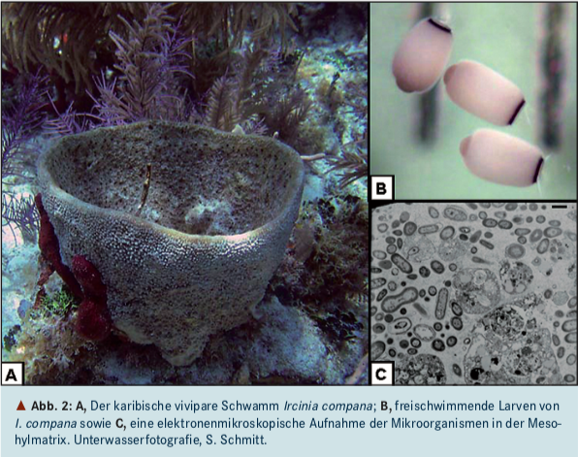

**Quelle:** Schmitt S., Hentschel, U. (2008), Sponges and microorgasm – an ancient association, BIOspektrum (14), p.142.

The relationship between a host sponge and bacteria is referred to in scientific studies as symbiotic when the same bacteria are present in sponges in different locations and these bacteria are not found in the surrounding water. Most likely, the bacteria are passed on to the sponge descendants by means of a combination of vertical (via larval stages[4]) and horizontal (influx of water) transference. In addition, the sponges exhibit a similarity in microbial pattern, independent of their place of habitation. The microorganisms can serve to provide the sponge with additional nutrients, to further stabilize their skeletal structure, or to fend off enemies.

The great hope of scientists is to use the sponges, with their great chemical diversity, to develop new medicines against infections and parasitic diseases and to discover new antibiotics. This work includes isolating the symbiotic bacteria from the sponges in order to extract active ingredients from them. This poses the particular challenge of how to breed large numbers of these symbiotic bacteria in the laboratory. Large-scale harvesting of sponges is not an environmentally compatible alternative. And so the scientific community must forge new pathways by synthesizing large amounts of the active ingredients from symbiotic microorganisms and making them useful for medical applications. Among the scientists engaged in this and other questions is Dr. Ute Hentschel Humeida, Professor of Marine Ecology at the GEOMAR – Helmholtz-Zentrum für Ozeanforschung (Center for Marine Research) in Kiel.

**Literatur:**

* Heering, P. (2013), Storytelling als Zugang zur Bildung in den Naturwissenschaften, Jena. URL: <http://www.phydid.de/index.php/phydid-b/article/viewFile/443/582> (access on 26.06.18)
* Kegel, B. (2015), Die Herrscher der Welt – Wie Mikroben unser Leben bestimmen, DuMont Verlag, Köln.
* Loy, A., Open Science – Lebenswissenschaften im Dialog (2017). URL: <http://www.openscience.or.at/files/articles/1017/e5418834fbcd6e7b98ba16cebbf7d6f5_mikrobiom-des-menschen-aufgabenblaetter.pdf> (access on 24.06.18)
* Hentschel, U., Bringmann, G. (2010), Suche nach neuen Wirkstoffen aus der Natur - Marine Schwämme: Füllhorne der Meere, Pharm. Unserer Zeit (39).
* Grabowski, V. (2002). Nachweis und Charakterisierung von Actinobakterien und einigen Planctomycetales aus marinen Schwämmen, S. 119-124.
* Hentschel U., Piel J. (2006), Abenteuer im Metagenom, Nicht kultivierte Bakterien – die versteckte Vielfalt. Vorbild Natur, 76-80.
* Schmitt S., Hentschel, U. (2008), Schwämme und Mikroorganismen – eine uralte Assoziation, BIOspektrum (14), 140-142.
* Hentschel Ute, Usher KM, Taylor MW. 2006. Marine sponges as microbial fermenters. *FEMS Microbiology Ecology* 55: 167–177.
* Hentschel Humeida, U. (2016), Mikrobielle und chemische Ökologie mariner Schwamm-Mikroorganismen-Interaktionen, Rundgespräche Ökologie, Dr. Friedrich Pfeil Verlag, München, S. 59-67.
* Ich bin META – Menschen, Tiere, Pflanzen & ihre mikrobiellen Mitbewohner (2017), Kiel.

Infobox: Stop-motion films using the storytelling method

A good story can change the world – the history of human evolution has proven it. This is true thanks to the doorkeeper to our long-term memory, the *amygdala*. It decides whether we commit something to memory or not. This is because the *amygdala* is in direct contact with the *hippocampus*, which plays a crucial role in memory formation. Not every story makes its way into our long-term memory bank, however, because over the course of human development only exciting stories had the potential to secure our survival.

Tips for creating a film:

* Limit the content of your story to the essentials
* Stories arouse emotions – they are easier to remember than disjointed fact
* The first sentence / introduction is crucial and should arouse curiosity (to get past the doorman)
* Create an arc of tension
* A good story engages the audience (listening is fun) and generates enthusiasm (for the idea or process)
* The listener identifies with the story and is better able to absorb information
* Story = character (hero/heroine) + predicament + desire/attempt to escape (see illustration)

The framework of a story

This is an example of a **storyboard**. The important thing is to prepare the template before you start shooting the film by entering the title, image and content into each frame! Enjoy making your film!

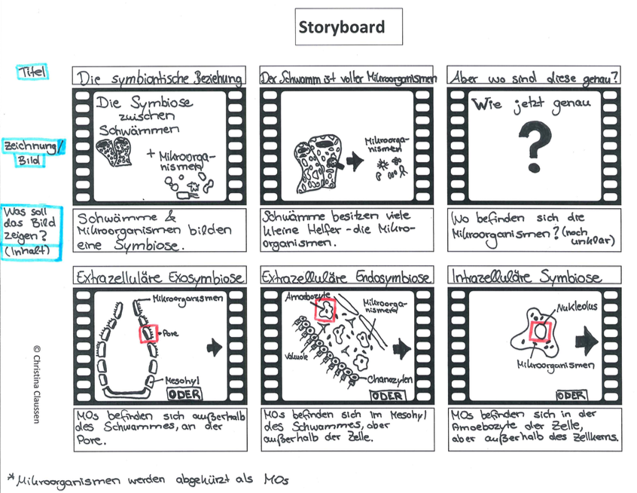

1. This method is used to determine the relationships between microorganisms. It uses the 16S rRNA gene sequence as a relationship marker.
2. In this method bacteria are hybridized using a fluorescent probe. They can be made visible within an original sample specifically and independent of cultivation method.
3. Gram negative rod-shaped bacteria which can transmit infections to humans, e.g. by means of lice or ticks.
4. Sponges can reproduce both asexually by budding and sexually (mostly hermaphrodites). In sexual reproduction sperm are released into the water and are concurrently taken up by the egg cell of a neighboring sponge. The larvae initially grow inside a cavity and are then released (planktonic larval stage up to sessile settlement of the young animal).

   *Microbiome: Totality of microorganisms which are associated with the sponge and colonize it.